Aim: To recommend an item to the user using content-based filtering approach
IDE: Google Colab

Theory:
There are a lot of applications where websites collect data from their users and use that data to predict the likes and dislikes of their users. This allows them to recommend the content that they like. Recommender systems are a way of suggesting or similar items and ideas to a user’s specific way of thinking.
Recommender System is different types:
- Collaborative Filtering: Collaborative Filtering recommends items based on similarity measures between users and/or items. The basic assumption behind the algorithm is that users with similar interests have common preferences.
- Content-Based Recommendation: It is supervised machine learning used to induce a classifier to discriminate between interesting and uninteresting items for the user.
Content-Based Recommendation System: Content-Based systems recommends items to the customer similar to previously high-rated items by the customer. It uses the features and properties of the item. From these properties, it can calculate the similarity between the items.
In a content-based recommendation system, first, we need to create a profile for each item, which represents the properties of those items. From the user profiles are inferred for a particular user. We use these user profiles to recommend the items to the users from the catalog.

Item profile:
In a content-based recommendation system, we need to build a profile for each item, which contains the important properties of each item. For Example, If the movie is an item, then its actors, director, release year, and genre are its important properties, and for the document, the important property is the type of content and set of important words in it.
Let’s have a look at how to create an item profile. First, we need to perform the TF-IDF vectorizer, here TF (term frequency) of a word is the number of times it appears in a document and The IDF (inverse document frequency) of a word is the measure of how significant that term is in the whole corpus.

User profile:
The user profile is a vector that describes the user preference. During the creation of the user’s profile, we use a utility matrix that describes the relationship between user and item. From this information, the best estimate we can decide which item the user likes, is some aggregation of the profiles of those items.

Advantages and Disadvantages:
- Advantages:
  - No need for data on other users when applying to similar users.
  - Able to recommend to users with unique tastes.
  - Able to recommend new & popular items

  - Explanations for recommended items.

Disadvantages:
  - Finding the appropriate feature is hard.
  - Doesn’t recommend items outside the user profile.

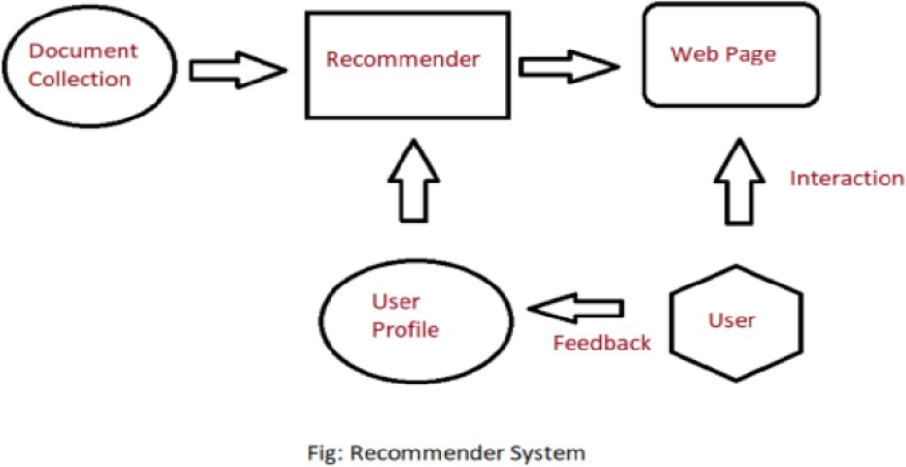

Pre Lab Exercise:

1. When can you use content-based recommendation system approach?
Content-based recommendation is used when the system recommends items based on similarity between item features and user preferences.

It is suitable when:

When user preference data is available (e.g., past likes, clicks, ratings)
When items have descriptive features (keywords, category, tags, attributes)
When new items are frequently added to the system
When you want personalized recommendations for each user
When user privacy is important (no need for other users’ data)

Example:
Netflix recommending movies based on genres you previously watched.

2. Write advantages of content-based filtering approach
- Provides personalized recommendations based on user interests
- Works even when few users are available
- No dependency on other users' data
- Can recommend new or unpopular items
- User preferences can be explained easily (based on item features)
- Avoids cold start problem for items

3. Write disadvantages of content-based filtering approach
- Needs detailed item features (metadata must be available)
- Overspecialization problem – recommends only similar items repeatedly
- Difficult to capture changing user interests
- Cannot recommend items outside user’s past preferences
- Feature extraction may be complex and time-consuming

Program (Code):

import pandas as pd

from sklearn.feature_extraction.text import TfidfVectorizer

from sklearn.metrics.pairwise import cosine_similarity

df=pd.read_csv("movies.csv")

#preprocessing step

df["genres"]=df["genres"].fillna("")

df["overview"]=df["overview"].fillna("")

df["content"]=df["genres"]+" "+df['overview']

#TF-IDF Vectorizer

tfidf=TfidfVectorizer(stop_words="english")

tfidf_matrix=tfidf.fit_transform(df["content"])

cosine_sim=cosine_similarity(tfidf_matrix,tfidf_matrix)

#droping the duplicates

indices=pd.Series(df.index,index=df["original_title"]).drop_duplicates()

def recommendation_movie(title,topn=5):

if title not in indices:

return "Movie is not found!"

idx=indices[title]

sim_scores=list(enumerate(cosine_sim[idx]))

sim_scores=sorted(sim_scores,key=lambda x:x[1],reverse=True)

sim_scores=sim_scores[1:topn+1]

movie_indices=[i[0] for i in sim_scores]

return df["original_title"].iloc[movie_indices]

recommendation_movie("Inception")

# ================= INSTALL KAGGLEHUB =================

!pip install kagglehub

# ================= IMPORT LIBRARIES =================

import pandas as pd

from sklearn.feature_extraction.text import TfidfVectorizer

from sklearn.metrics.pairwise import cosine_similarity

import kagglehub

import os

# ================= DOWNLOAD DATASET =================

path = kagglehub.dataset_download("harshitshankhdhar/imdb-dataset-of-top-1000-movies-and-tv-shows")

print("Dataset Path:", path)

# ================= LOAD DATA =================

df = pd.read_csv(os.path.join(path, "imdb_top_1000.csv"))

# ================= PREPROCESS =================

df["Genre"] = df["Genre"].fillna('')

df["Overview"] = df["Overview"].fillna('')

df["content"] = df["Genre"] + " " + df["Overview"]

# ================= TF-IDF =================

tfidf = TfidfVectorizer(stop_words="english")

tfidf_matrix = tfidf.fit_transform(df["content"])

# ================= COSINE SIMILARITY =================

cosine_sim = cosine_similarity(tfidf_matrix, tfidf_matrix)

# ================= INDEX MAPPING =================

indices = pd.Series(df.index, index=df["Series_Title"]).drop_duplicates()

# ================= RECOMMEND FUNCTION =================

def recommend_series(title, topn=10):

if title not in indices:

return "Series not found!"

idx = indices[title]

sim_scores = list(enumerate(cosine_sim[idx]))

sim_scores = sorted(sim_scores, key=lambda x: x[1], reverse=True)

sim_scores = sim_scores[1:topn+1]

series_indices = [i[0] for i in sim_scores]

return df["Series_Title"].iloc[series_indices]

# ================= OUTPUT =================

print("Top 10 Recommended Series:\n")

print(recommend_series("Inception", 10))

Results:
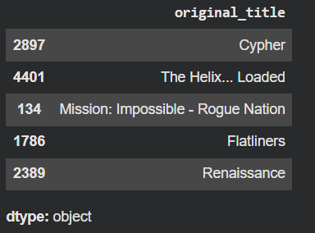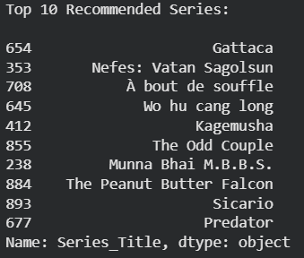

Observation:
The system recommends movies/series based on similar content (Genre + Overview) using TF-IDF and cosine similarity.
For the input "Inception", it suggests items with similar textual features.

This shows the model is a content-based recommendation system, as it depends on item similarity and not on other users’ data.

Some results may not seem very accurate because TF-IDF checks word similarity, not full meaning.

Post Lab Exercise:
- What changes you feel can be done, to improve the system that you have designed, as a part of in-house lab exercise.
- Use more features
Include additional columns like cast, director, keywords, ratings to improve recommendation accuracy.
- Apply advanced NLP techniques
Use Word2Vec, BERT, or embeddings to understand the actual meaning of text, not just keywords.
- Remove irrelevant words
Perform text preprocessing such as stemming and lemmatization for better similarity matching.
- Combine with Collaborative Filtering
Use hybrid recommendation system (content + user behaviour) for better results.

- Recommend top-10 “series” using IMDB movie dataset
(Link: https://www.kaggle.com/datasets/harshitshankhdhar/imdb-dataset-of-top-1000- movies-and-tv-shows). Attach the code with output. Also, write your observation for the same.
Code:
# install kagglehub
!pip install kagglehub

# import libraries
import pandas as pd
from sklearn.feature_extraction.text import TfidfVectorizer
from sklearn.metrics.pairwise import cosine_similarity
import kagglehub
import os

# download dataset
path = kagglehub.dataset_download(
"harshitshankhdhar/imdb-dataset-of-top-1000-movies-and-tv-shows"
)

# load dataset
df = pd.read_csv(os.path.join(path, "imdb_top_1000.csv"))

# preprocessing
df["Genre"] = df["Genre"].fillna("")
df["Overview"] = df["Overview"].fillna("")

# combine features
df["content"] = df["Genre"] + " " + df["Overview"]

# TF-IDF
tfidf = TfidfVectorizer(stop_words="english")
tfidf_matrix = tfidf.fit_transform(df["content"])

# cosine similarity
cosine_sim = cosine_similarity(tfidf_matrix, tfidf_matrix)

# index mapping
indices = pd.Series(df.index, index=df["Series_Title"]).drop_duplicates()

# recommendation function
def recommend_series(title, topn=10):

if title not in indices:
return "Series not found"

idx = indices[title]

sim_scores = list(enumerate(cosine_sim[idx]))

sim_scores = sorted(sim_scores,
key=lambda x: x[1],
reverse=True)

sim_scores = sim_scores[1:topn+1]

series_indices = [i[0] for i in sim_scores]

return df["Series_Title"].iloc[series_indices]

# output
print("Top 10 Recommended Series:\n")

print(recommend_series("Inception",10))

Output:
